**INTERNAL ASSIGNMENT**

**Course Code: OMC209 Last Date of Submission: 31/07/24**

**Course Title: Advanced Java Programming Laboratory Maximum Marks: 30**

**Note:**

* The scanned code snippets (handwritten only) of all the 12 lab programs should be included in a word document.
* Screenshots of the output for all possible inputs should also be included in the document at the end of each program.
* Follow the naming convention for the documents:

**OMC209\_StudID\_Name\_Lab\_Manual.pdf**

* Make sure the scanned code and screenshots of the output are clearly visible.

1. **Program 1**  
   Create an Android application that displays the message:  
   *“Welcome to Graphic Era University MCA”* on the screen.

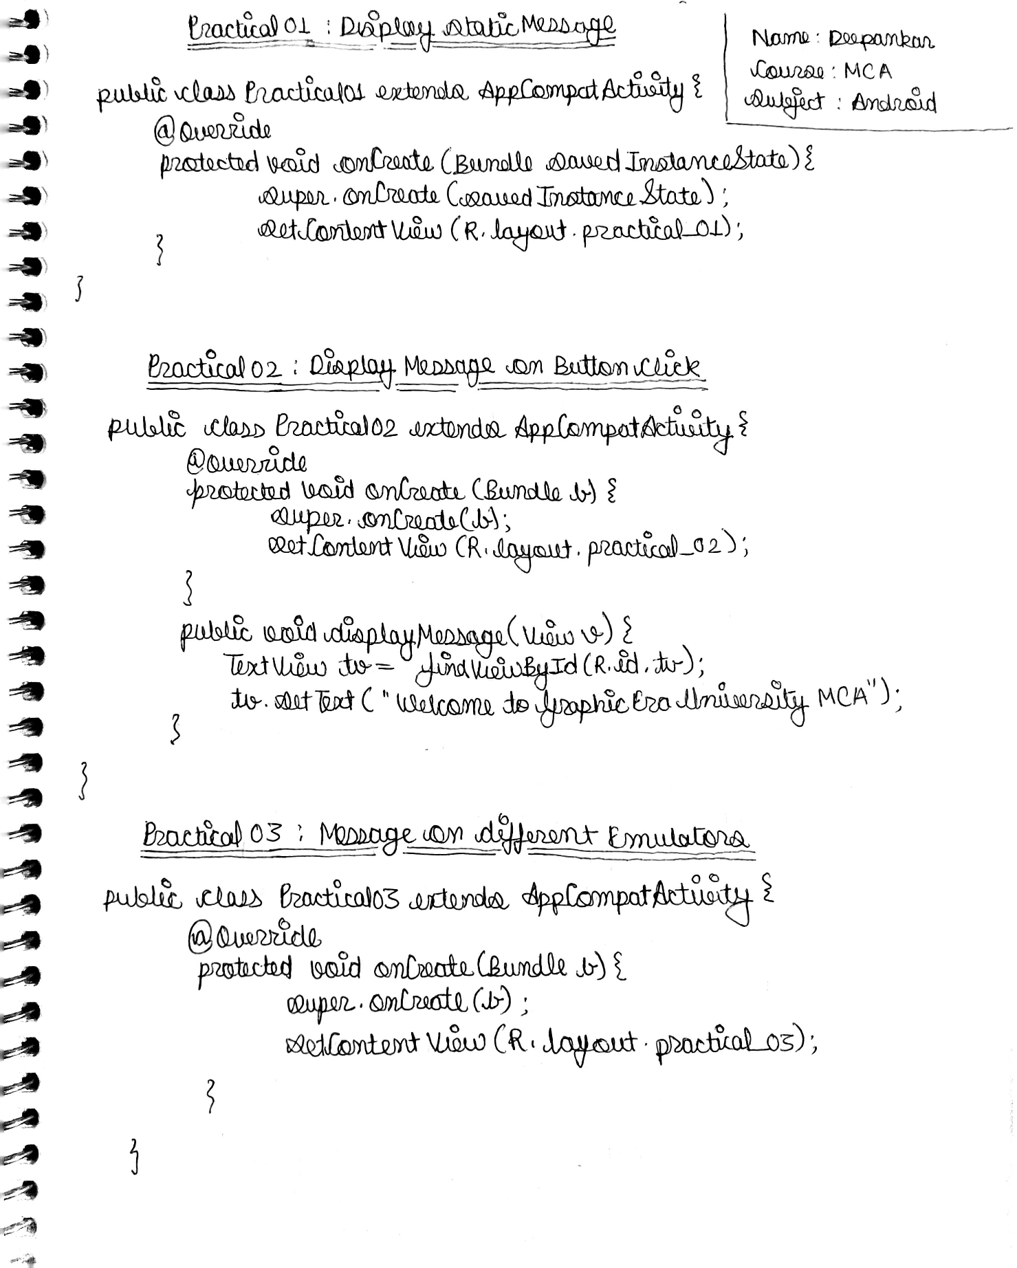

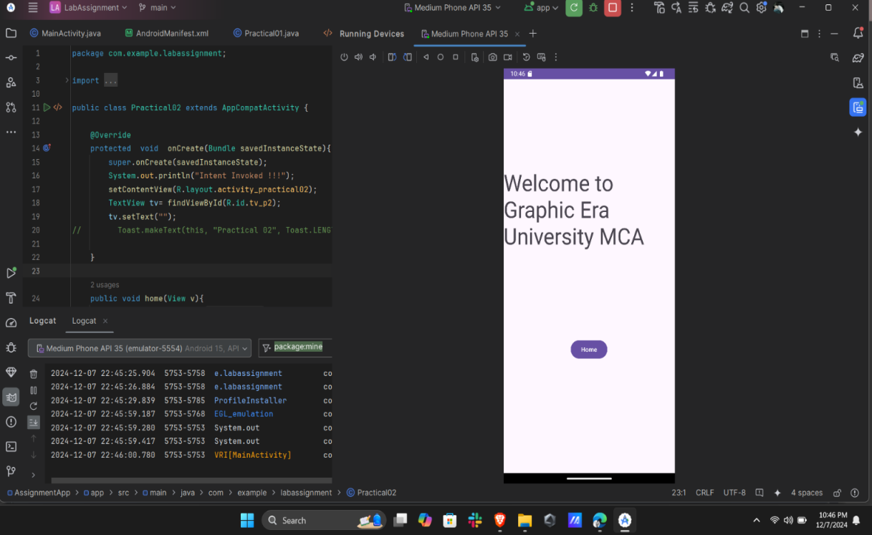

Practical 01

1. **Program 2**  
   Create an Android application that displays the message:  
   *“Welcome to Graphic Era University - MCA”* when a button is clicked.

|  |  |
| --- | --- |
| IMG_256 | IMG_256 |

Practical 02

1. **Program 3**  
   Create an Android application to display the message:  
   *“Welcome to GEU - learning Android Application Development - MCA”*  
   and execute the application using different emulators.

|  |  |
| --- | --- |
| IMG_256  Medium Phone API | IMG_256  Pixel 6 Pro |

1. **Program 4**  
   Illustrate with a suitable example the use of **Toast** to display a message in an Android application.  
   *[The message display should wait for a long time]*

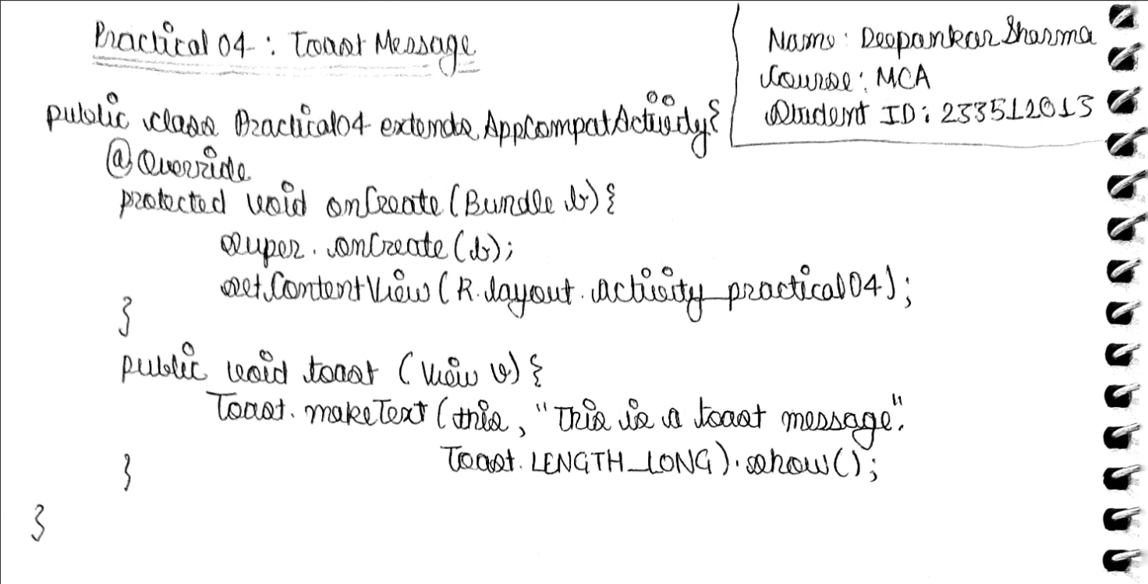

1. **Program 5**  
   Create an Android application for designing a simple calculator with the following basic functionalities:
   * Addition
   * Subtraction
   * Multiplication
   * Division  
     Use controls like **Buttons**, **TextViews**, and **EditTexts**.

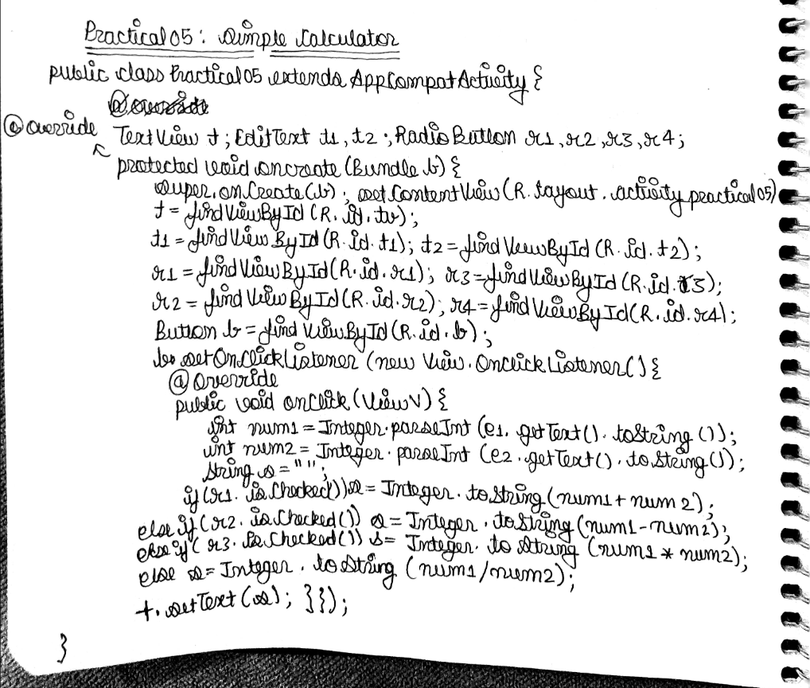

1. **Program 6**  
   Illustrate with a suitable example the use of **Intents** for linking activities.  
   *[At least two activities should be used]*

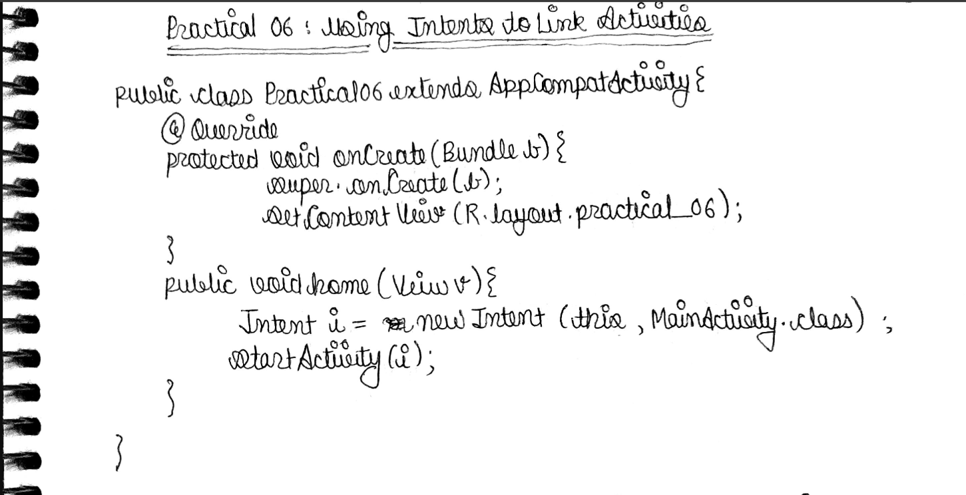

1. **Program 7**  
   Illustrate with a suitable example the use of **Intents** for navigating to a website.  
   *[Navigate to Graphic Era University Website]*

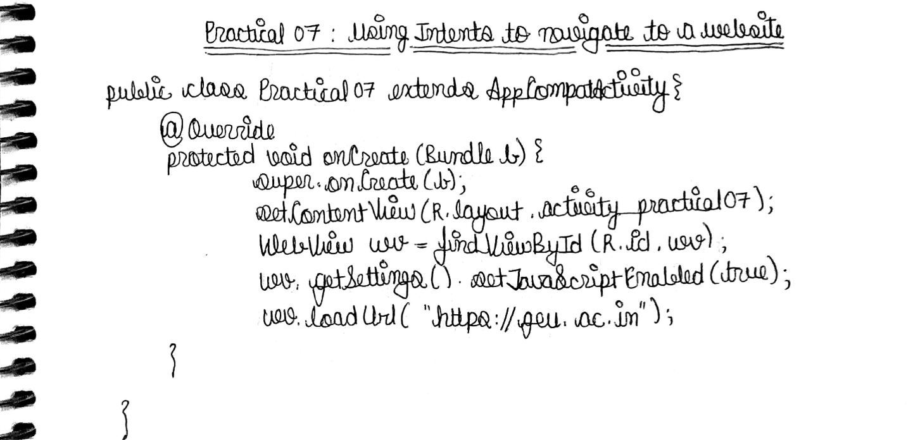

1. **Program 8**  
   Create an Android application that demonstrates the use of **Relative Layout** in Android by using appropriate views to create a login form.

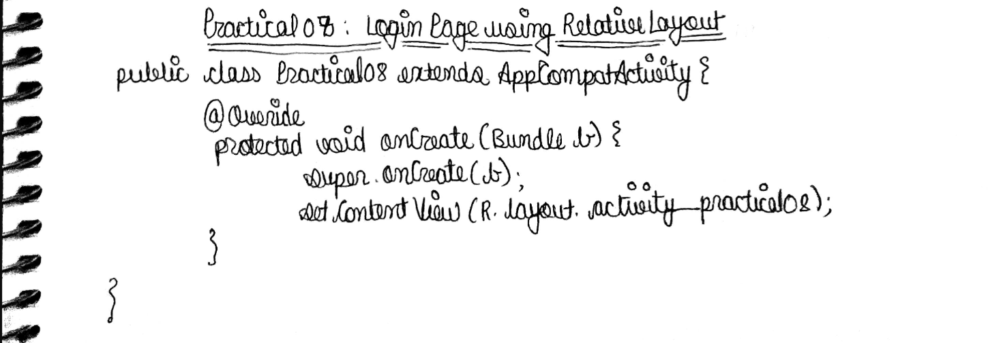

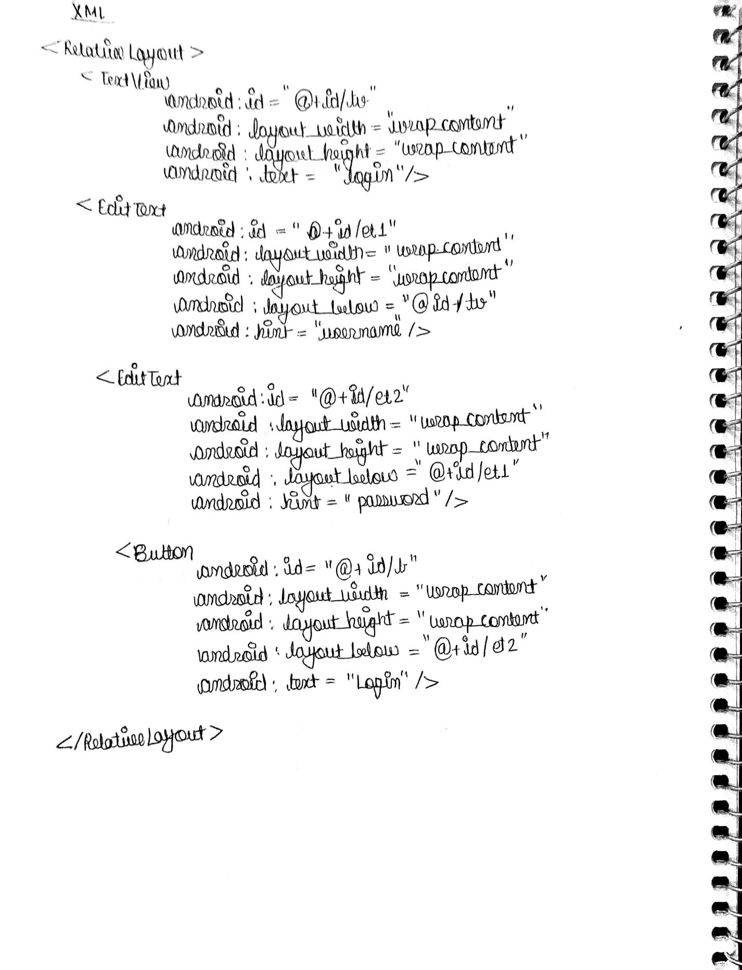

1. **Program 9**  
   Create an Android application that demonstrates the use of appropriate layouts and views to create a Registration Form  
   *[For intercollege sports events]* and display the message:  
   *“Registration is successful”* on the click of a Submit button.

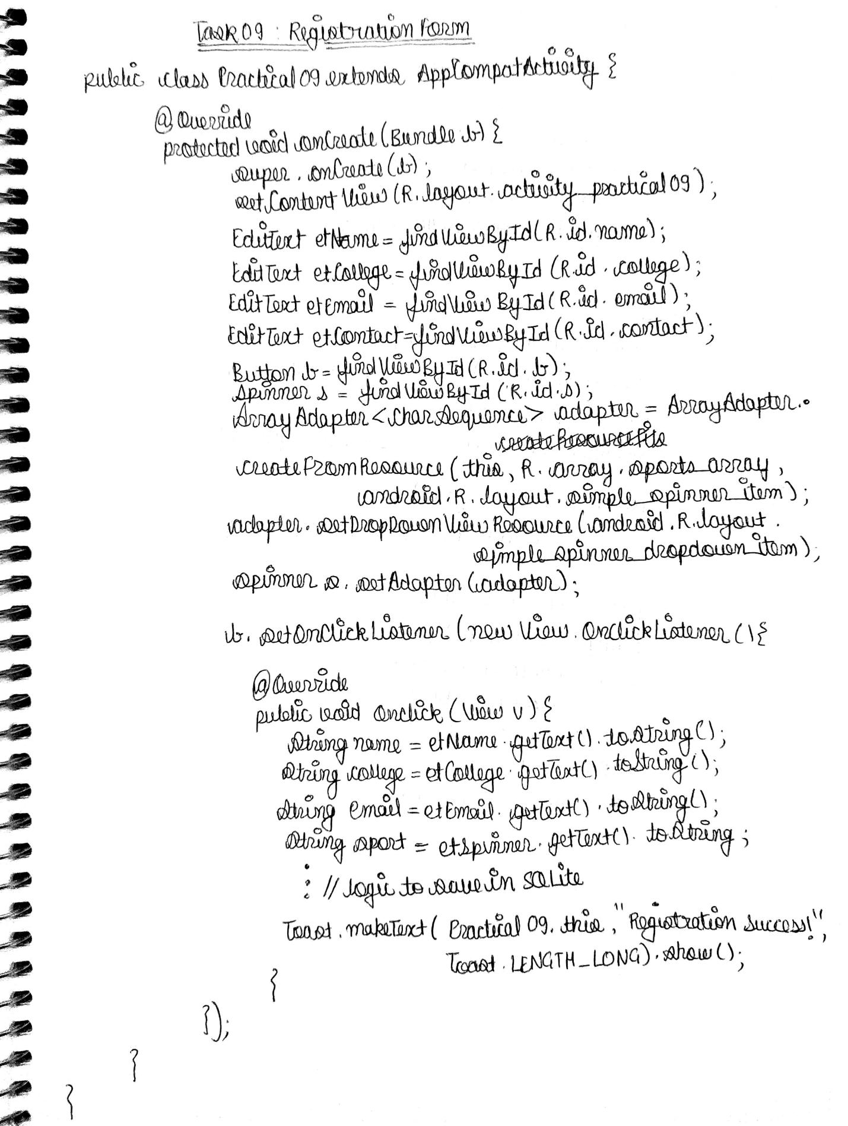

1. **Program 10**  
   Illustrate with a suitable example the use of graphics for displaying the following shapes:
   * Circle
   * Triangle
   * Rectangle

